ANOVA

Enter all your data with each group in a separate column.

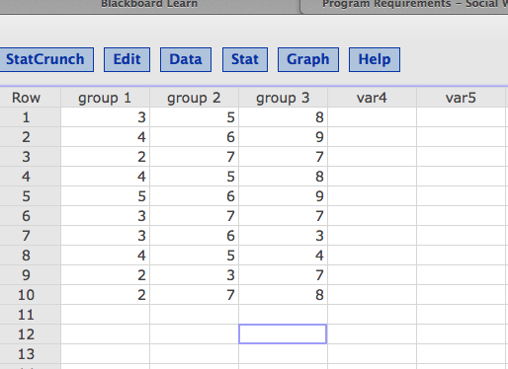

Click > stat > ANOVA > one-way.

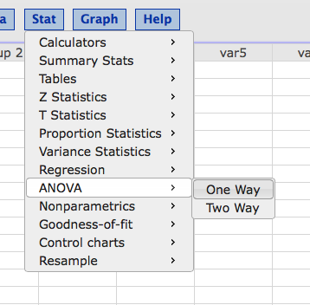

Select all three groups, click Tukey box.

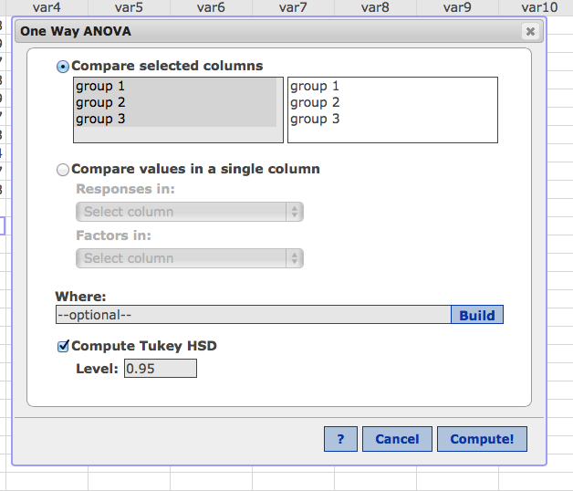

Hit compute.

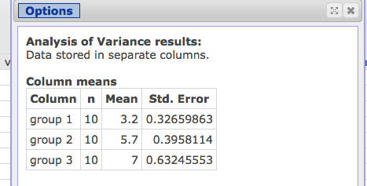

First section is all the means (useful for the post hoc test).

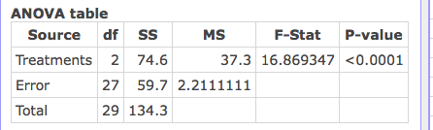

Second section is the main ANOVA table.

SS – useful for effect size calculations (remember SStreatment / SS total = R squared)

Df – df treatment = between; df error = within; step 2

MS – MS treatment = between, MS error = within; step 2

F stat = step 4

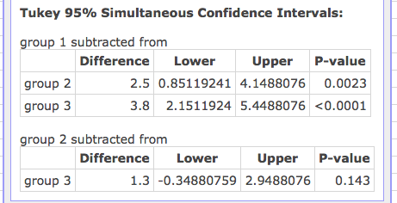

Post hoc test example!

Tukey (remember this is a correction).

|  |  |  |  |  |
| --- | --- | --- | --- | --- |
| Group 1 | Group 2 | P-value | Comparison | Reject? |
| 3.2 | 5.7 | .0023 | .05 | Yes group 1 lower |
| 3.2 | 7 | .0001 | .05 | Yes group 1 lower |
| 5.7 | 7 | .143 | .05 | NO groups equal |

To do Bonferroni or Scheffe!

Repeat beginning steps with ANOVA, but only select TWO groups at a time.

Bonferroni

Comparison = .05 or .01 / number of post hocs

(here = .05 / 3 = .0167)

|  |  |  |  |  |
| --- | --- | --- | --- | --- |
| Group 1 | Group 2 | P-value | Comparison | Reject? |
| 3.2 | 5.7 | .0001 | .0167 | Yes group 1 lower |
| 3.2 | 7 | .0001 | .0167 | Yes group 1 lower |
| 5.7 | 7 | .0985 | .0167 | NO groups equal |

Stat > ANOVA > One Way

Just did 1 versus 2

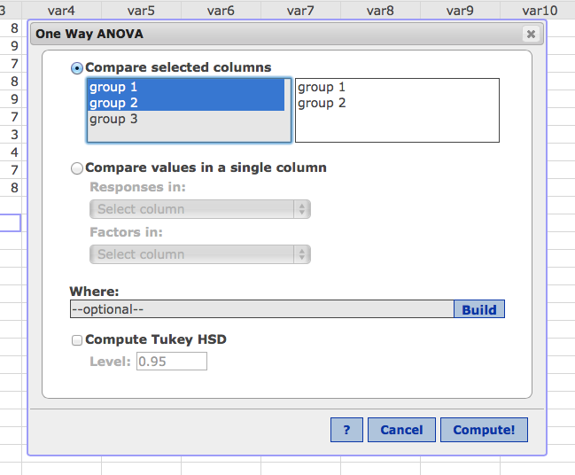

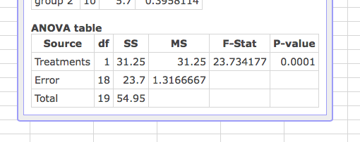

(repeated this with 1 vs 3 and 2 vs 3)

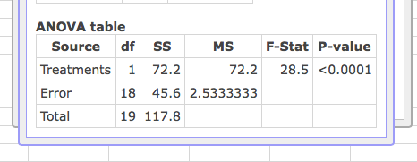

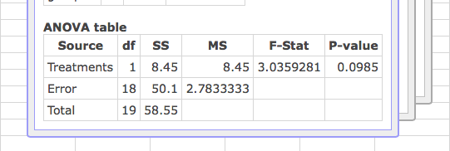

Scheffe

We will calculate the comparison F values (same steps as above, but look at F-Stat rather than P-value). Then to correct, we divide by dfbetween from step 2. (here that’s 2). Do not use df between from each of these follow up ANOVAs. Compare that to your original step 3 cut off (for 2, 27 p<.05 = 3.36)

|  |  |  |  |  |
| --- | --- | --- | --- | --- |
| Group 1 | Group 2 | F value / dfbn | Comparison | Reject? |
| 3.2 | 5.7 | 23.73 / 2 = 11.87 | 3.36 | Yes group 1 lower |
| 3.2 | 7 | 28.5 / 2 = 14.25 | 3.36 | Yes group 1 lower |
| 5.7 | 7 | 3.04 / 2 = 1.52 | 3.36 | NO groups equal |